Project Design Phase-II
Data Flow Diagram & User Stories

Date | 6 July 2026
Team ID
Project Name | Online Complaint Registration System
Maximum Marks | 4 Marks

Data Flow Diagrams:
A Data Flow Diagram (DFD) represents how data moves through the Online Complaint Registration System. It shows the interaction between users, agents, administrators, application processes, and the database.
The DFD explains how complaint information is submitted, processed, assigned, updated, and stored within the system.
Components of Data Flow Diagram:
The Data Flow Diagram of the Online Complaint Registration System contains the following main components:
1. User Module:
Allows users to register, login, submit complaints, and track complaint status.
2. Authentication Process:
Verifies user credentials and provides role-based access for Users, Agents, and Administrators.
3. Complaint Management:
Handles complaint submission, assignment, status updates, and resolution process.
4. Admin and Agent Module:
Admin manages users, agents, and complaints, while agents handle assigned complaints and update progress.
5. Database:
MongoDB stores user information, complaint details, agent data, and status records securely.

Example: 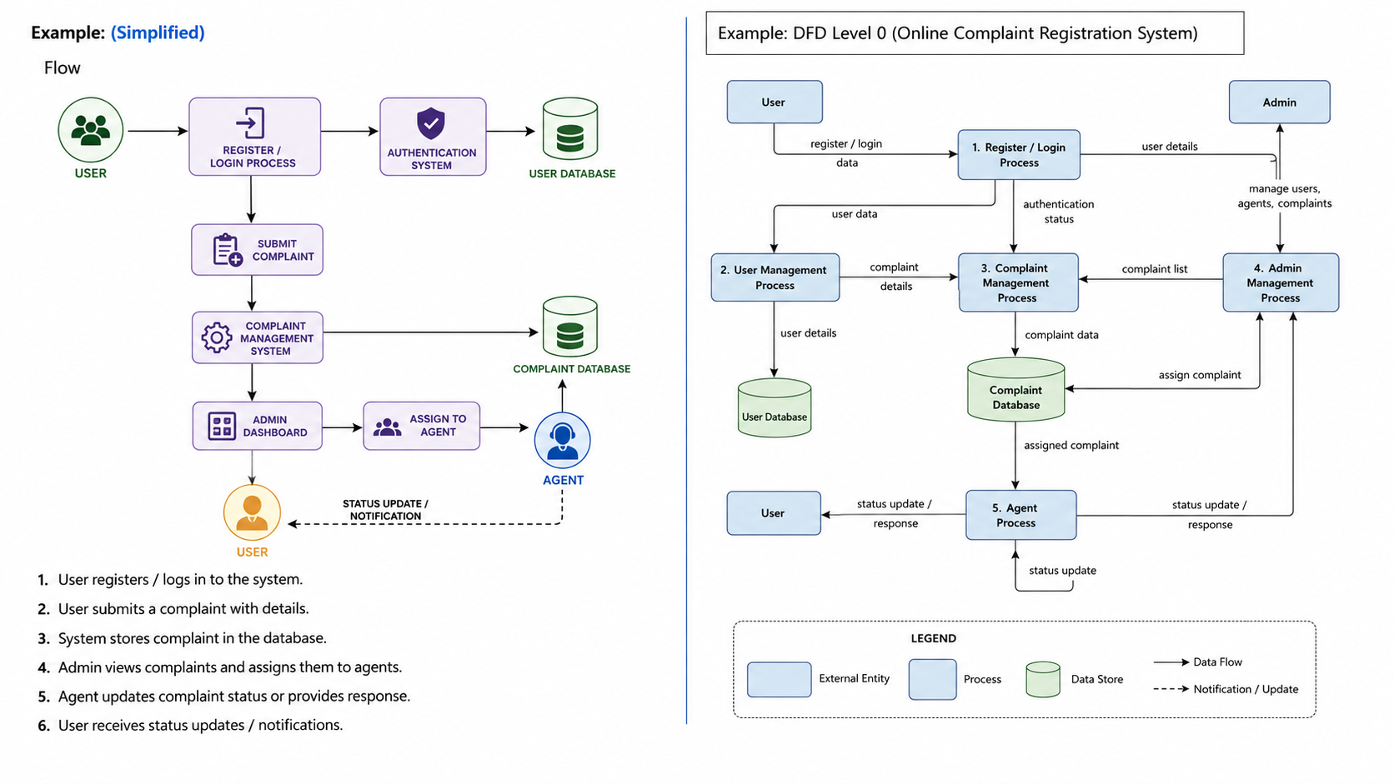

User Stories
Use the below template to list all the user stories for the product.
User Type | Functional Requirement (Epic) | User Story Number | User Story / Task | Acceptance criteria | Priority | Release
User | Registration | USN-1 | As a user, I can register into the application by entering my name, email, and password. | User account should be created successfully and stored in database. | High | Sprint-1
User | Login | USN-2 | As a user, I can login using my registered email and password. | User should access dashboard after successful authentication. | High | Sprint-1
User | Complaint Registration | USN-3 | As a user, I can submit a complaint by entering complaint details. | Complaint should be saved and visible in my complaint list. | Low | Sprint-2
Agent | Complaint Tracking | USN-4 | As a user, I can check the current status of my submitted complaints. | complaint status should be displayed correctly. | Medium | Sprint-1
Agent | View Complaints | USN-5 | As an agent, I can view complaints assigned by the administrator. | Assigned complaints should appear in agent dashboard. | High | Sprint-1
Agent | Update Status | USN-6 | As an agent, I can update complaint progress and resolution status. | Updated status should reflect in user's complaint tracking page. | High | Sprint-2
Administrator | Manager Users | USN-7 | As an admin, I can view and manage registered users. | Admin should be able to access user details securely. | Medium | Sprint-1
Administrator | Assign Complaints | USN-8 | As an admin, I can assign user complaints to available agents. | Complaint should successfully move to selected agent. | High | Sprint-1
Administrator | Dashboard | USN-9 | As an admin, I can monitor total users, agents, and complaints. | Dashboard should display correct system statistics. | Medium | Sprint-1

